European YMCA
Youth Workers Camp 2022
Colours against discrimination

Do you like Europe?
We invite you to take part in one week Europe at it’s best: The YMCA Youth Workers Camp 2022 for volunteers in the YMCA.
More than 80 young volunteers between 16 and 30, from different European YMCAs will meet from July 23rd – 31st 2022 in Camp Storkow/Germany.
You will share your experiences in youth work in different social backgrounds, you will present your youth work, you will discover diversity as a treasure for yourself and for the society, you will be challenged by migrant volunteers and their experiences and you will develop your own personality and you will have a lot of fun.
To take part in this camp you should speak and understand English, you should have participated in a volunteer course and you should have some experiences in youth work.

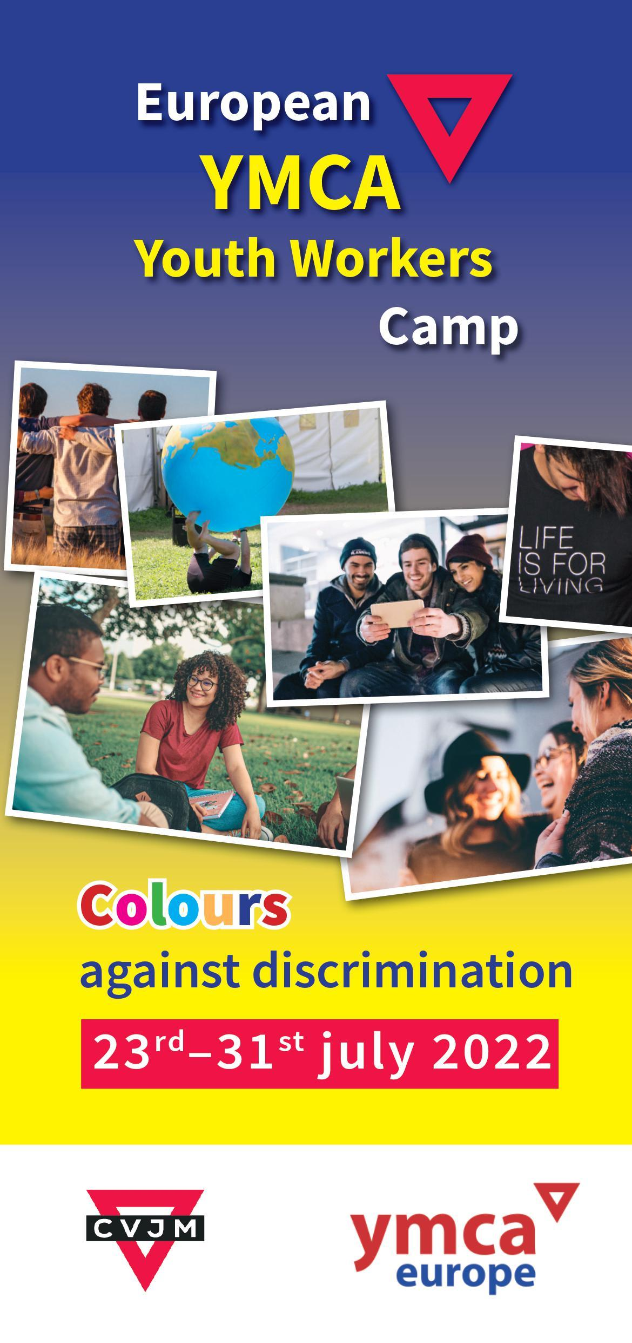
Theme: Colours against discrimination
Date: 23. – 31.07.2022
Prep. Camp: 22. - 24.04.2022 (for invited participants only)
Venue: Camp Storkow, www.cvjm-camp.de
Accommodation: Cabins with 6 - 10 beds and tents
Participants: 80 + 20 leaders
Age: 16 – 30
Language: English
Participants from: Czech Republic, Germany, Iceland, Malta, Russia, Kosovo, Slovakia, Sweden, Slovakia, Hungary
Team: Markus Rapsch, Beate Turck, Volker Kamin
Participation fee: € 150,- incl. accommodation, food, programme Travel: To be organised by yourself or your national movement
Reimbursement: of travel costs according to grants from Erasmus +
Certificate: Every participant will get a Youth Pass Certificate

Programme: Each participant can choose one course:
- Intercultural dialogue, YMCA youth work training
- Treehouse building and outdoor-experiences
- Experiential learning in sport and movement
- Music, dance, drama, camp-band
- Multi media & social media
- Mental health

Information: Markus Rapsch, mailto:storkow2021@cvjm-westbund.de
Registrations: Via your national YMCA office
Organised by: CVJM-Westbund, Bundeshöhe 6, 42285 Wuppertal/Germany
Registration
European YMCA Youth Workers Camp 23.- 31.July 2022 in Storkow/Germany

Name, first name:
Gender:
Street:
City code, City:
Birthday: E-Mail:

⬜ Pupil/Student ⬜ Trainee ⬜ Volunteer ⬜ Profession
Allergies or other relevant health limitations? ⬜ NO ⬜ YES Vegetarian ⬜ Vegan ⬜
Others? _______________________________________
Member in YMCA:
I am a YMCA volunteer in the field of: since:
I have participated in the following volunteer educations:
My English is ⬜ basic ⬜ good ⬜ perfect
I do the following sports:
I play/ed this instrument:
Other hobbies:
Did you take part in other international camps?
⬜ No ⬜ YES ⬜ as participant ⬜ as volunteer/leader
⬜ Your responsibilities in the camp: _____________________
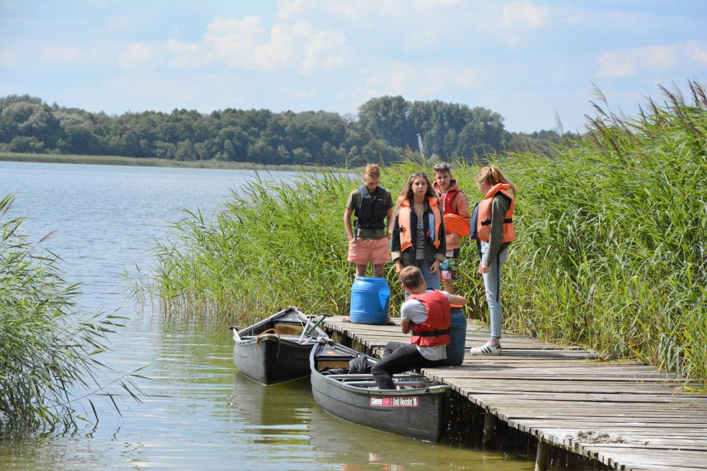
I would choose the following course in the camp:
⬜ 1 Intercultural dialogue, YMCA youth work training
⬜ 2 Treehouse building and outdoor-experiences
⬜ 3 Experiential learning in sport and movement
⬜ 4 Music, dance, drama, camp-band
⬜ 5 Multi media & social media
⬜ 6 Mental heath
Please choose your first and second course!
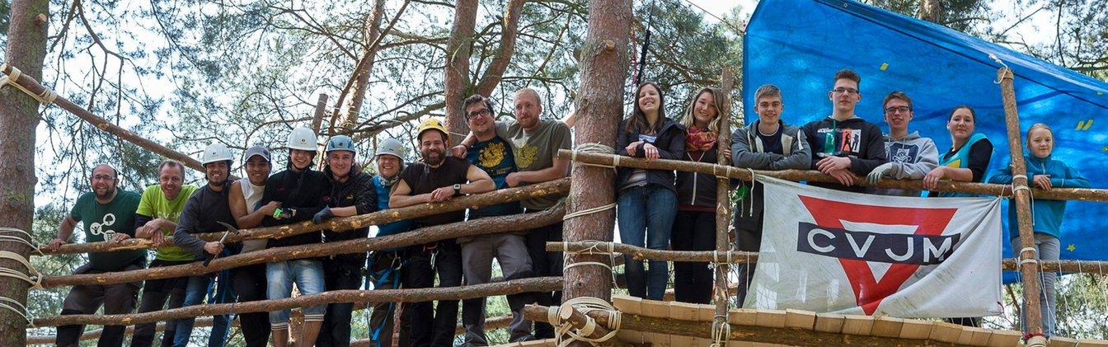
My second choice would be: ___________
Describe your motivation and your expectations in the YMCA Youth Workers Camp:
My biggest motivation is to meet a lot of new, young and driven leaders that share my interest in making a difference in the world. I expect to learn a lot about how other countries work in their YMCA and I hope to get some inspiration so that I can improve the organisation that I am from.

REGISTRATION
This is my binding registration for the European YMCA Youth Workers Camp
from 23.- 31.07.2022 in Storkow / Germany:
Place, date: Signature
If under 18: Confirmation of a parent or legal guardian needed:
Date Signature
This registration is only valid with a confirmation from CVJM-Westbund e.V.(sent out 28.04.2022)
and the reception of the participation fee. The fee will be refunded if the camp has to be canceld, because of Corona restrictions.

⬜ I am interested to participate in the planning weekend April 22.- 24. 2022 in Storkow/Germany.

Confirmation of a reference person:
I confirm the above-mentioned information and I recommend the applicant as a participant in the European YMCA Youth Workers Camp
YMCA Responsible leader: Emma Andersson

City, Date: Signature:

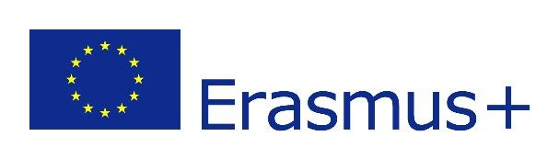
Return to: This project is funded by:
CVJM Westbund c/o Markus Rapsch
mailto:storkow2021@cvjm-westbund.de
Arbeitsgemeinschaft der Evangelischen Jugend in Deutschland e.V. (aej)

